**Devops 8**

**Demonstrate use of docker commands to pull ubuntu official image, create a file and push updated image on Dockerhub.**

1) Docker Installation from chrome

2)

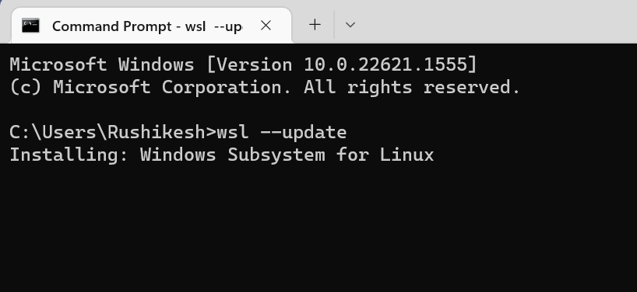

If above command doesn’t work

3) 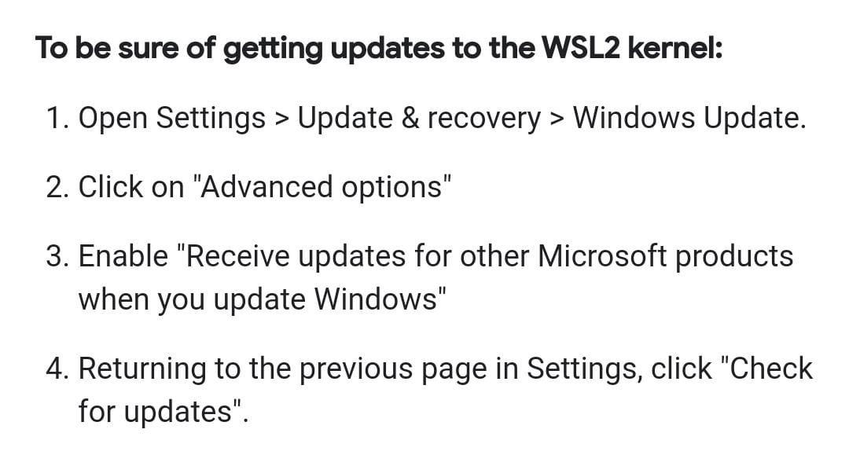

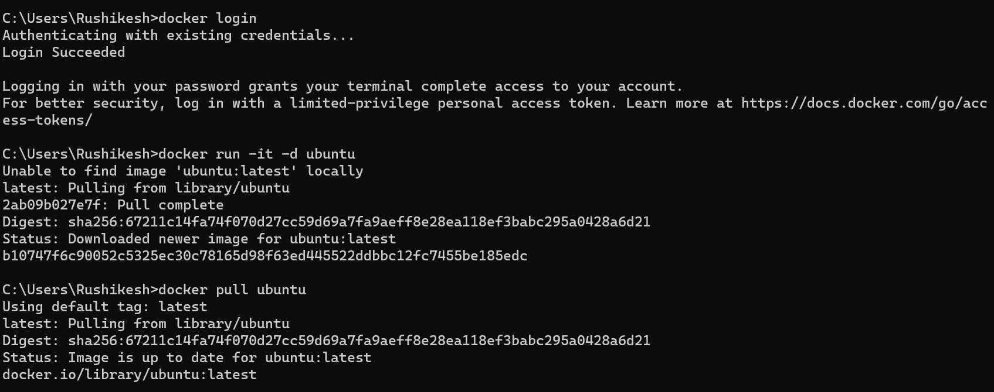

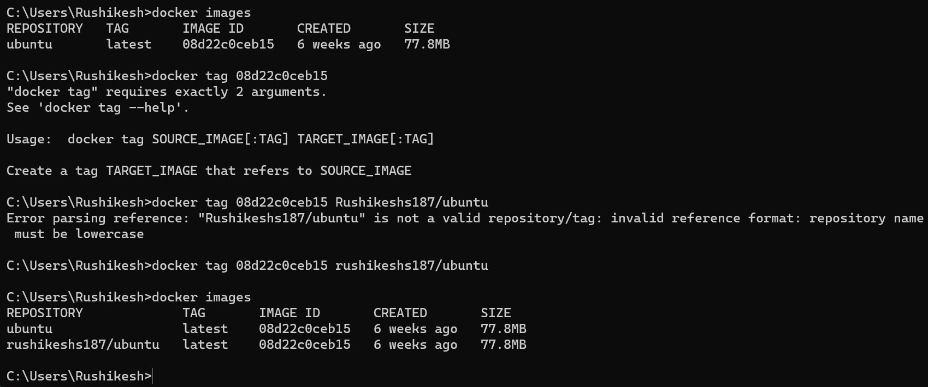

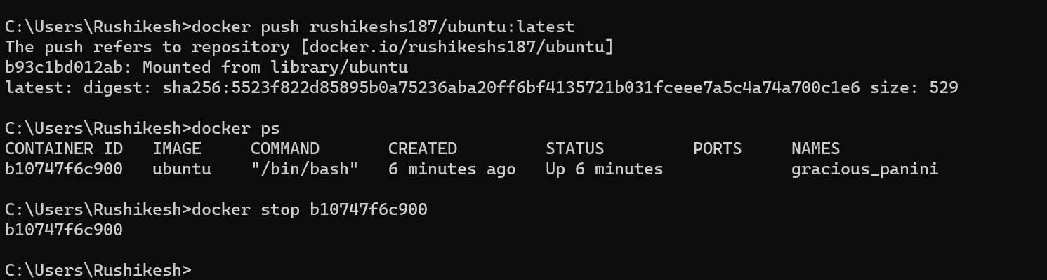

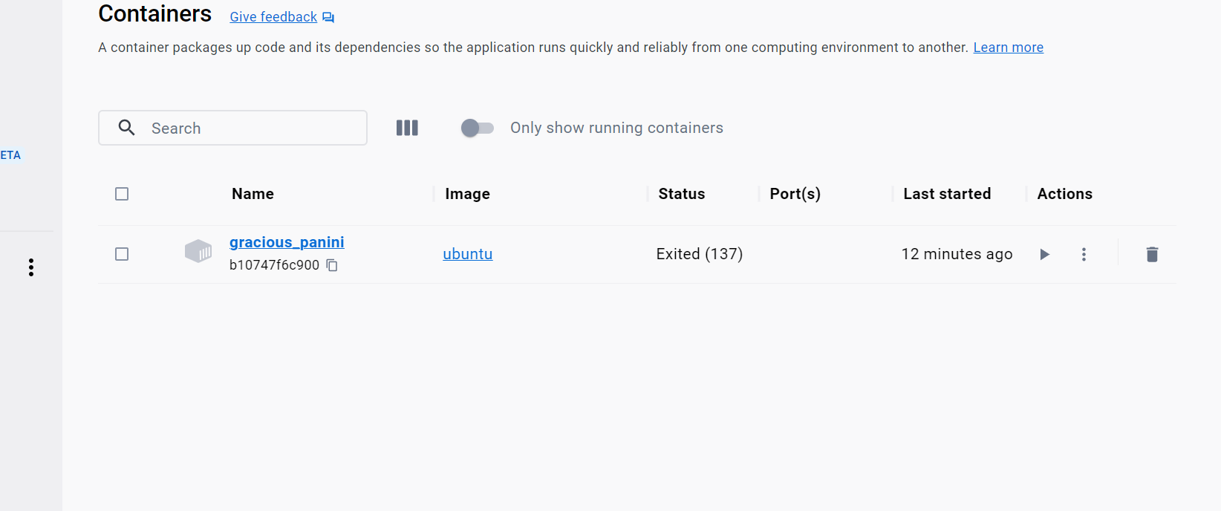

**Devops – 6**

**6. Write a Selenium script to perform automated testing.**

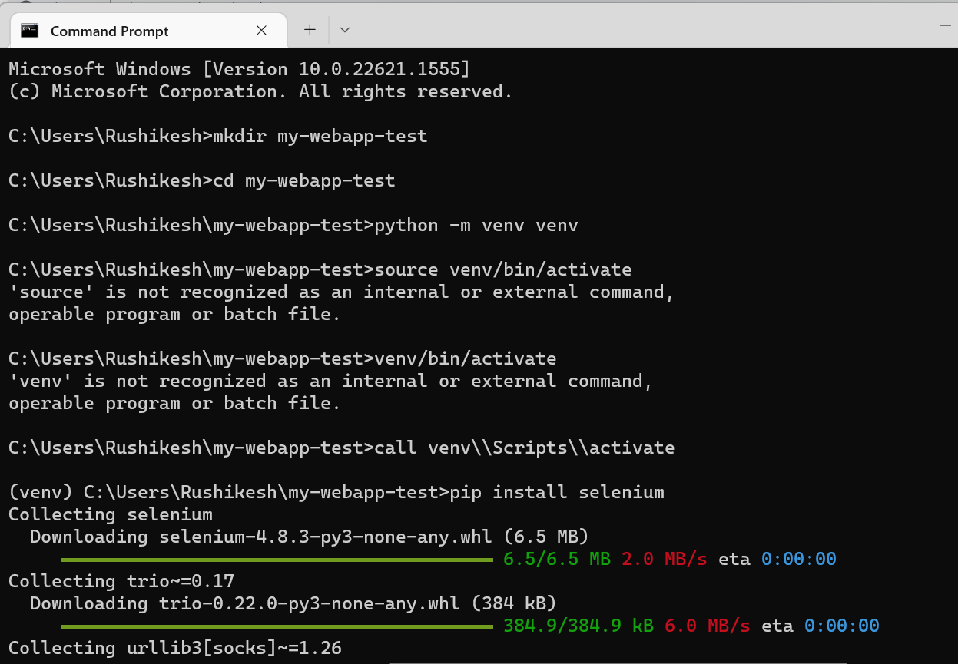

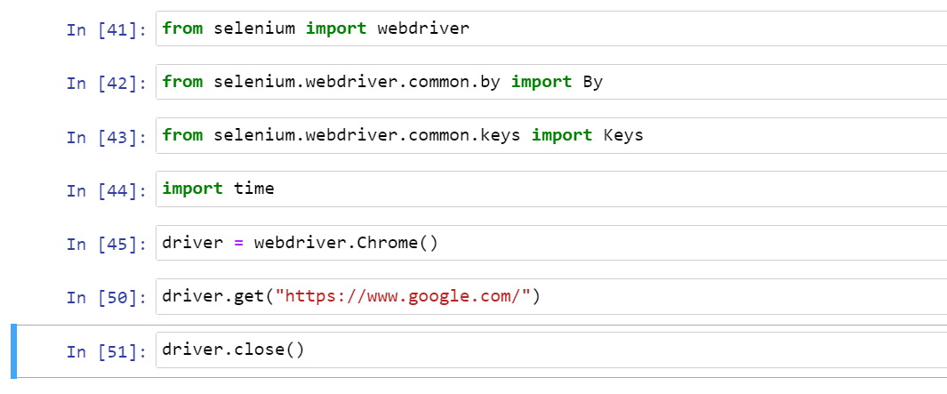

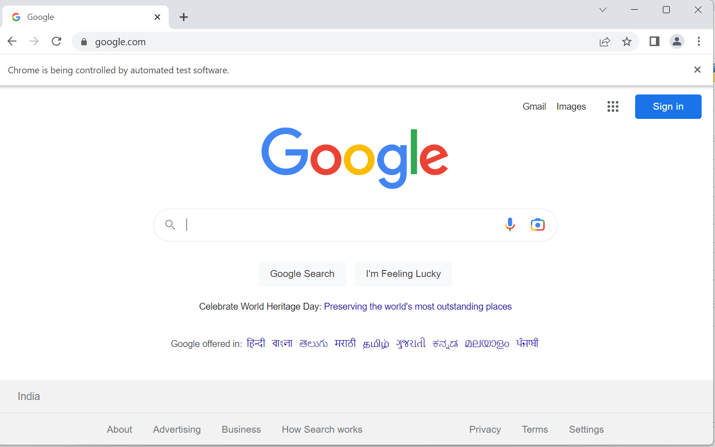

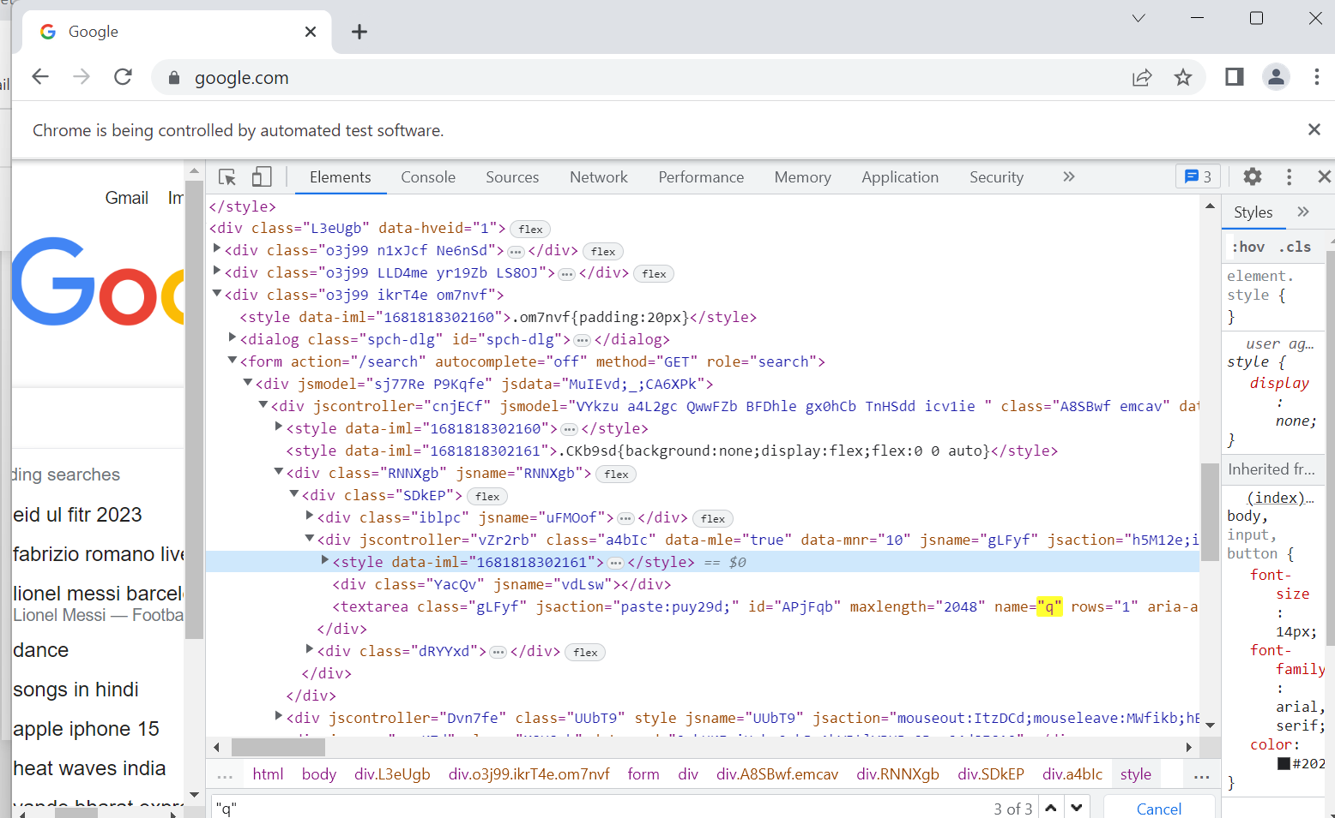

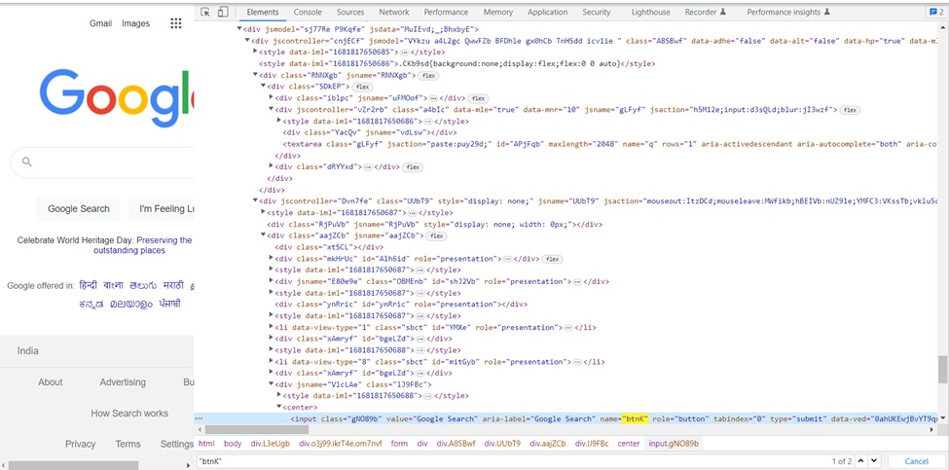

Devops – 7-Create an image of php project and push on Dockerhub repository

**index.php file (If html code throws errors try in notepad)**

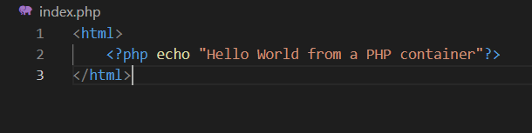

**Dockerfile:**

create a file called Dockerfile (without any extension) and write the below code into the file. Now with Docker file let construct an image.

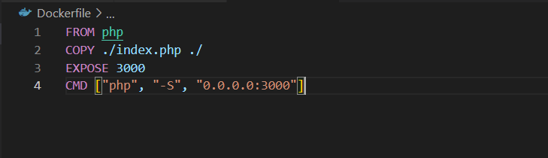

**docker build:**

**docker build .-t rushikeshs187/php**

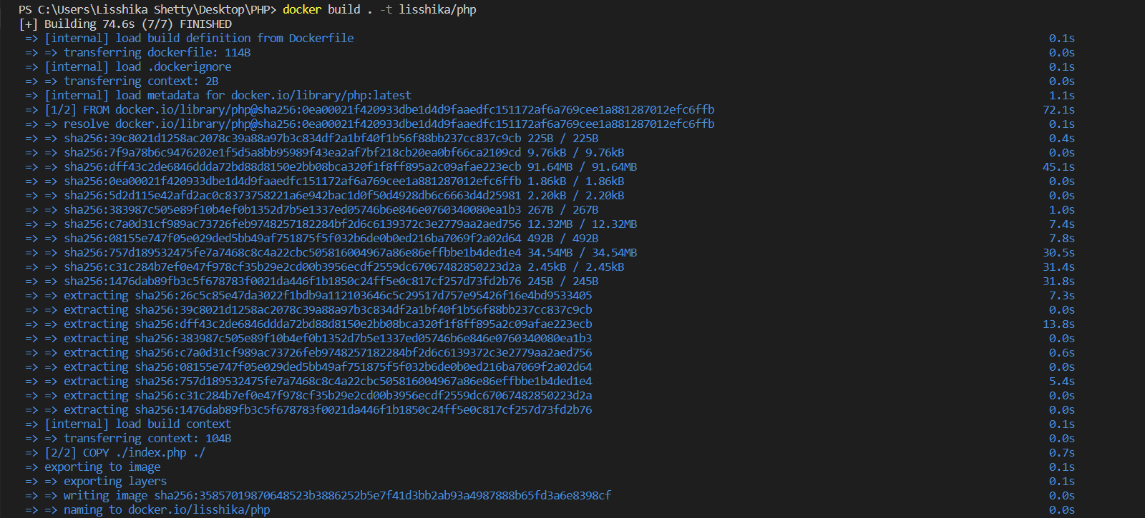

docker run –name=php -p=3000:3000 rushikeshs187/php

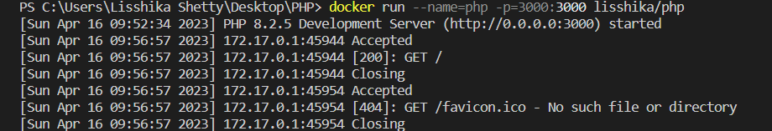

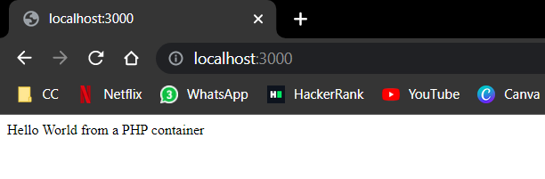

**Devops – 2**

Demonstrate Building java program (addition of 2 numbers) through Jenkins.

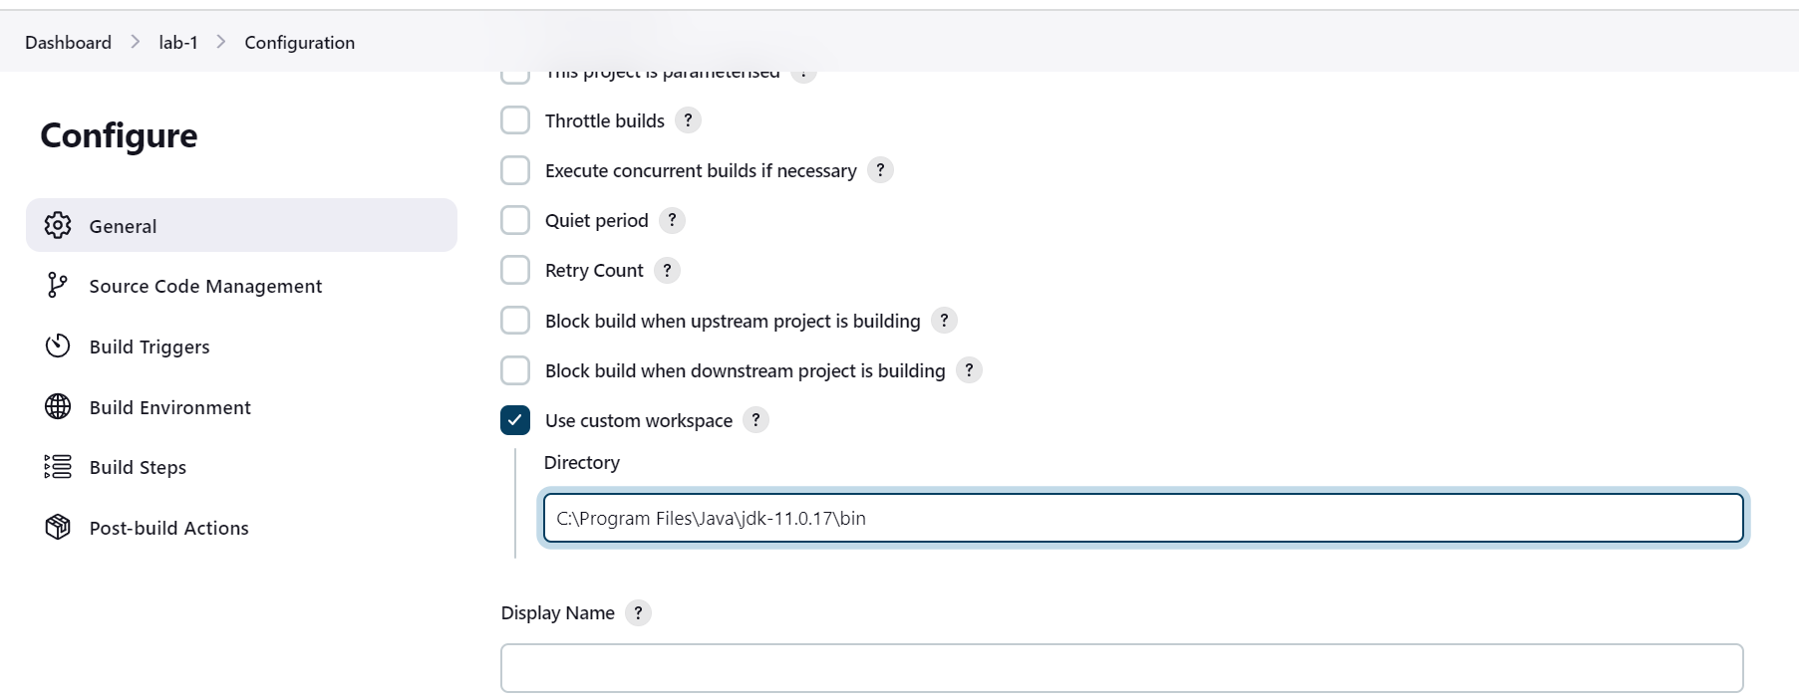

class Main {

public static void main(String[] args) {

int first = 10;

int second = 20;

// add two numbers

int sum = first + second;

System.out.println(first + " + " + second + " = " + sum);

}

}

Note Class with be the name of the file

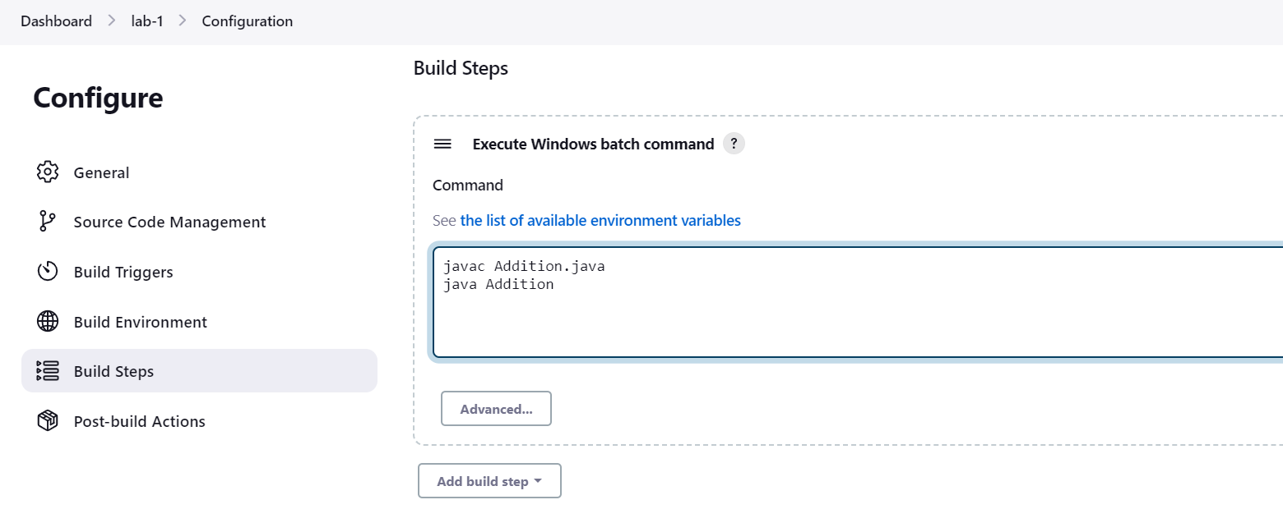

**Devops – 3**

Demonstrate Continuous Integration process in Jenkins. Build a java program every 2 minutes (addition of two numbers) residing in Github repository.

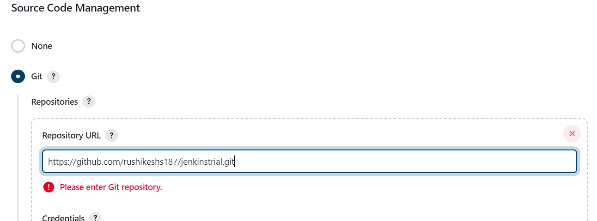

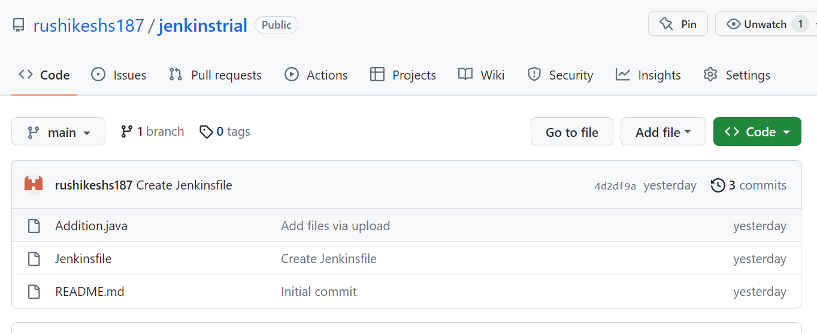

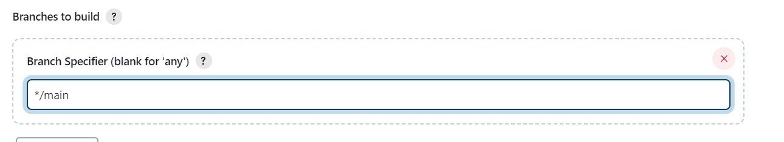

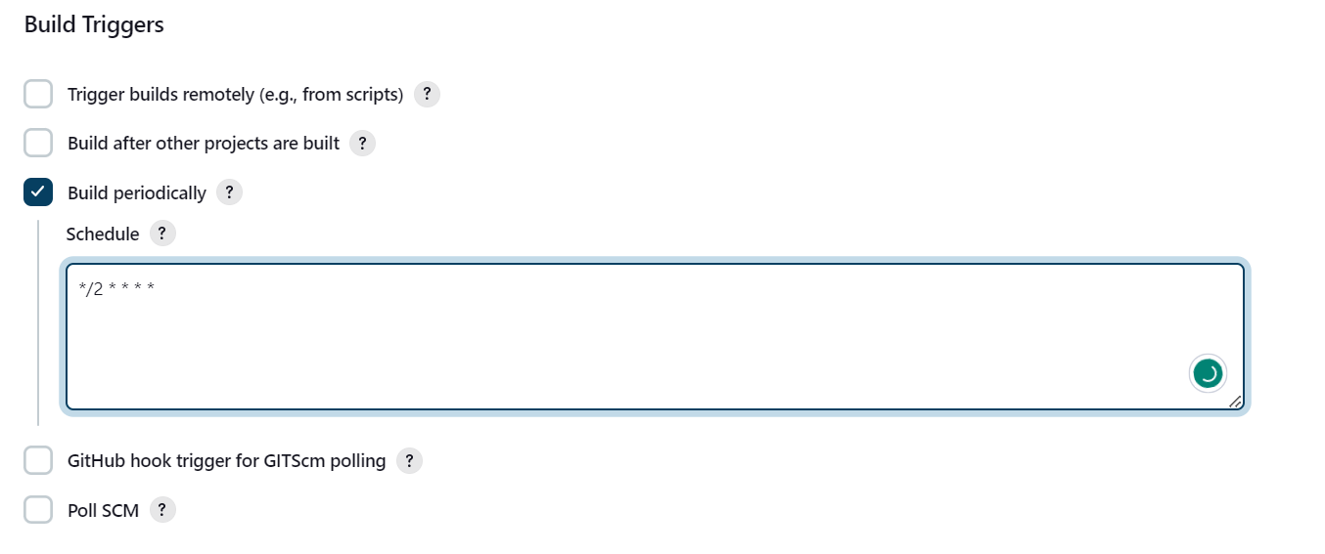



**Devops – 1**

**git config --global user.name "w3schools-test" // put your username in quotes**

**git config --global user.email "test@w3schools.com" // put your email in quotes**

**mkdir myproject**

**cd myproject**

**git init**

**<Create html and css files in myproject folder>**

**ls**

**git status**

**git add --all**

**git status**

**git commit -m "First release of Hello World!"**

**git remote add origin <github repo link> // put the github repo link**

**git push --set-upstream origin master**

**git fetch origin**

**git push origin**

**change something**

**git pull origin**

